GRASP Cloning Kit Supporting Doc – How to create CDS Parts
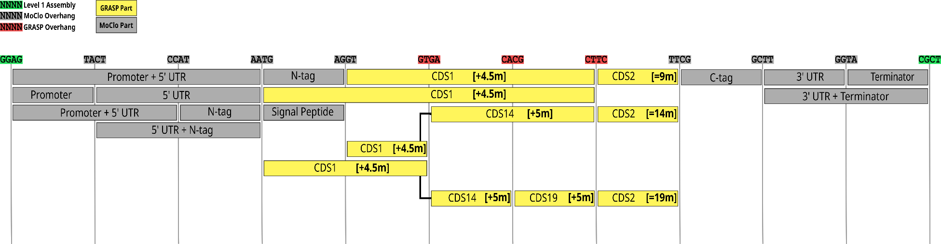
Above: How GRASP fits in the MoClo standard to create PPRs with 9, 14, or 19 motifs.
Level 0 Assembly Template: substitute the plasmid concentrations (green cells), or dilute GRASP parts to 100 ng/uL to simplify
Recommended Golden Gate cycling conditions: |  | While 26 cycles are usually sufficient for level 0 assembly, we recommend cycling for the maximum 60 cycles overnight (~10 hours) to maximise assembly success.  Ensure plasmid preps are of high quality (free of RNA/gDNA/ single-stranded plasmid). Plasmids should be quantified using Qubit HS/BR dsDNA kits.
37°C | 1 min
37°C | 5 min | } 26 - 60x
16°C | 5 min | } 26 - 60x
65°C | 20 min
12°C | HOLD

