Dial-Out PCR Protocol for Individual Gene Isolation from the Fluorescent Protein Libraries

Overview
The DropSynth fluorescent protein libraries (C1P & C2P) contain beta-barrel fluorescent proteins (FPs) spanning a large portion of the spectrum. To isolate specific variants, dial-out PCR (Schwartz et al., Nat Methods. 2012 Aug 12;9(9):913–915. doi: 10.1038/nmeth.2137) can be used to reliably retrieve individual fluorescent protein genes from this barcoded plasmid library.

Method:
Use a variant-specific forward primer (complementary to the gene start region) and a barcode-specific reverse primer (complementary to a known barcode sequence associated with that variant). This "dial-out" approach enables retrieval of a single clone from a diverse pooled library. This method has a ~70% success rate in our hands.

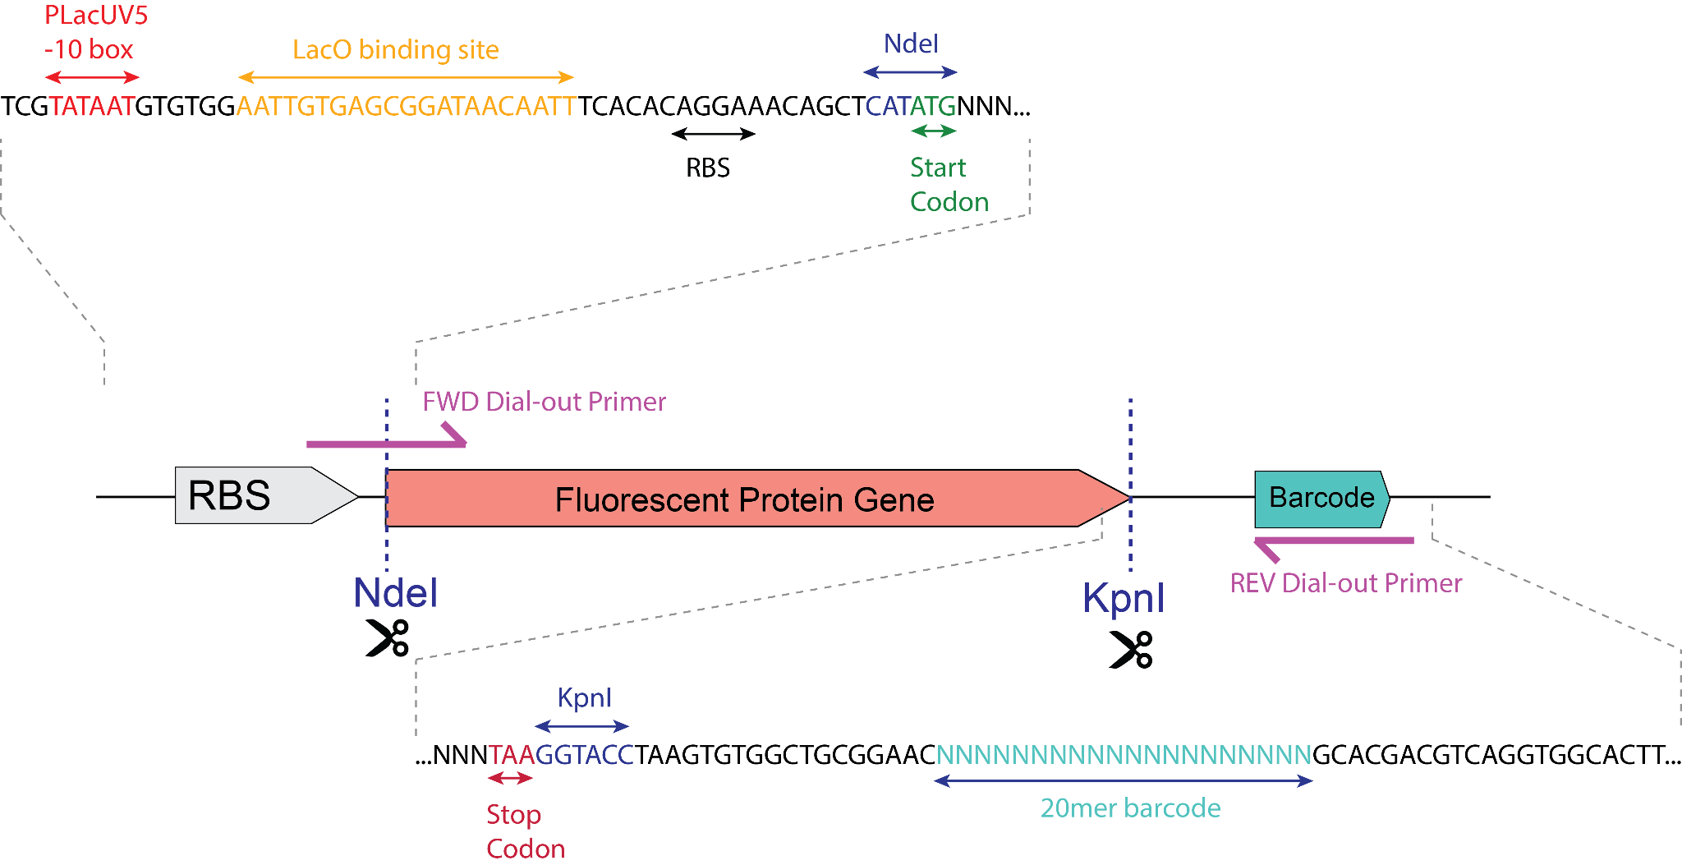

Materials Needed
- C1P & C2P barcoded plasmid library (e.g., pEVBC1-based)
- Variant coding sequence and associated barcode(s)
- Dial-out primers:
  - Forward primer: complementary to 5′ start of the coding sequence. Include the KpnI site or add your own sites as required for cloning.
  - Reverse primer: Complementary to barcode region. You can extend this primer on the 5’ end to include some of the conserved flanking sequence if higher Tm is needed.
  - See the mapping csv files (https://doi.org/10.6084/m9.figshare.30585419.v1) for potential pre-designed primers for each barcode/gene.

- Q5 PCR kit (or equivalent high-fidelity polymerase)
- EtSSB (NEB #M2410 or similar)
- Restriction enzymes: NdeI and KpnI
- T4 DNA Ligase and buffer (e.g., NEB)
- E. coli cloning strain (e.g., Top10 or NEB 5-alpha)
- LB carb media, LB carb bacterial plates
- Drop dialysis membranes (MCE Membrane Filter, 0.025 μm Pore Size, hydrophilic VSWP02500)

Primer Design Guidelines
- When designing primers, aim for annealing temperatures in the high 60s °C.
- Reverse primers may need to include part of the conserved region 5′ to the barcode to ensure sufficient Tm (for low GC barcodes).
- Choose barcodes with high read counts or well-defined clusters (from NGS data).
- Choose barcodes where a majority consensus call was made (see mapping csv files).
- For variants with multiple barcodes, run separate reactions or design a multiplexing strategy. (select one barcode, or have different variants for each one)
- For cloning you can use the existing NdeI/KpnI sites flanking the gene or add new restriction sites into your primers.

IV. Template Preparation
After miniprepping the library from a high efficiency transformation, use 2 ng of plasmid library DNA as template for dial-out.

V. Touchdown PCR to Amplify Specific Variant (Initial Amplification)
This touchdown PCR uses Q5 High-Fidelity DNA Polymerase. Touchdown PCR enhances specificity.

Reaction Setup (25 µL total):

Component Volume
5× Q5 Master Mix……………...5 µL
10 µM Forward Primer………..1.25 µL
10 µM Reverse Primer………..1.25 µL
Template (10 ng)......................1 µL
EtSSB (500 µg/mL stock)*........0.5–2.0 µL
Nuclease-Free Water………….to 25 µL

* EtSSB is optional but recommended for improved specificity. Use a final concentration of 5–20 ng/µL (i.e., 0.5–2.0 µL from 500 µg/mL stock per 25 µL reaction). A good starting point is 1 µL.

Cycling Conditions:

Initial denaturation: 98°C for 3 min

- 10 cycles of touchdown:
  - 98°C for 30 sec
  - 76°C → 66°C (−1°C/cycle) for 30 sec
  - 72°C for 30 sec
- 15-25 additional cycles:
  - 98°C for 30 sec
  - 66°C for 30 sec
  - 72°C for 30 sec
- Final extension: 72°C for 7 min
- Hold: 12°C

Post-PCR Cleanup:
- Purify using a PCR cleanup kit and use low elution volume (we used 18 µL). If yield is low, continue to reamplification.

VI. Reamplification (Optional)
Perform if initial PCR yield is insufficient.

- Use the same primers and polymerase as touchdown PCR, but increase the number of cycles.
- During cleanup, pool multiple reactions if needed.
- Cleanup with PCR purification kit; elute in 50 µL (for four pooled reactions).

Typical yield with Thermo column purification kit after pooling: 90-200 ng/µL.

VII. Insert Preparation for Cloning
Digest Dial-Out PCR Product:

Component Volume
10× CutSmart Buffer ………5 µL
NdeI…………………………..1 µL
KpnI…………………………..1 µL
Dial-out PCR product……….variable (use ~1 ug)
Nuclease-Free Water……….to 50 µL

- Incubate at 37°C for 2 hours to overnight.

- Note: NdeI is less efficient than KpnI-HF - extended incubation improves digestion.

- Optional: Verify insert size via agarose gel before gel extraction and column purification. It’s unlikely, but sometimes dial-out primers do amplify truncated inserts from the library.

VIII. Vector Preparation

- Digest pEVBC1 plasmid backbone with NdeI/KpnI as above.
- Gel-purify linearized vector and elute in low volume.
- Drop-dialyze both backbone and insert for 20–45 min before ligation.

IX. Ligation

- Use NEB T4 DNA Ligase protocol.
- A 2:1 insert:vector molar ratio should be sufficient (e.g.: 0.06 pmol insert : 0.02 pmol vector)
- Incubate overnight at 16°C
- Heat-inactivate: 80°C for 20 min
- Purify ligation using a column kit (e.g., Thermo)
- Drop-dialyze before transformation if doing electroporation.

X. Transformation and Validation
- Transform into chemically competent or electrocompetent E. coli (e.g., Top10 or NEB 5-alpha)
- Plate on carbenicillin selection (if using pEVBC1 backbone)
- Confirm correct clones via:
  - Colony PCR (primers flanking insert)
  - Plasmid sequencing

