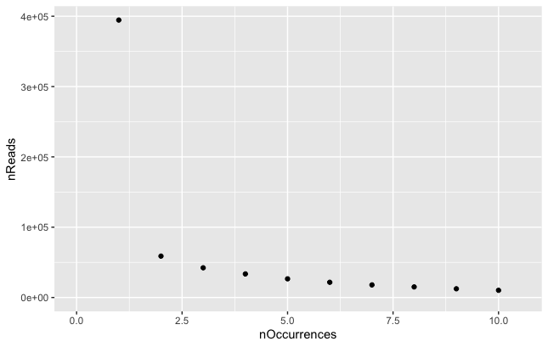
The frequency distribution of sequencing reads for unique barcodes in the library as measured by amplicon sequencing.

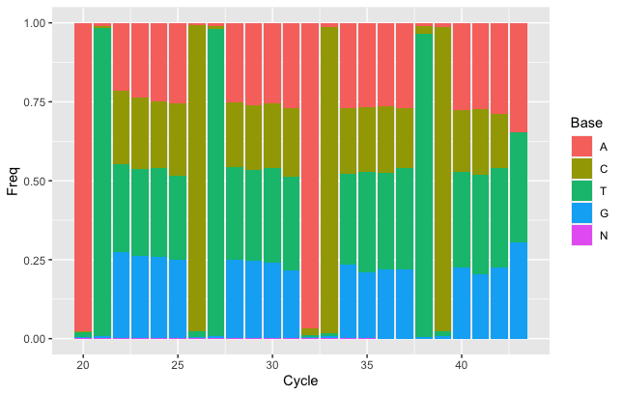
The distribution of nucleotides by base within the barcode region.

