“All-in-one” system for inducible expression of sgRNA –
tet-pLKO-sgRNA-puro

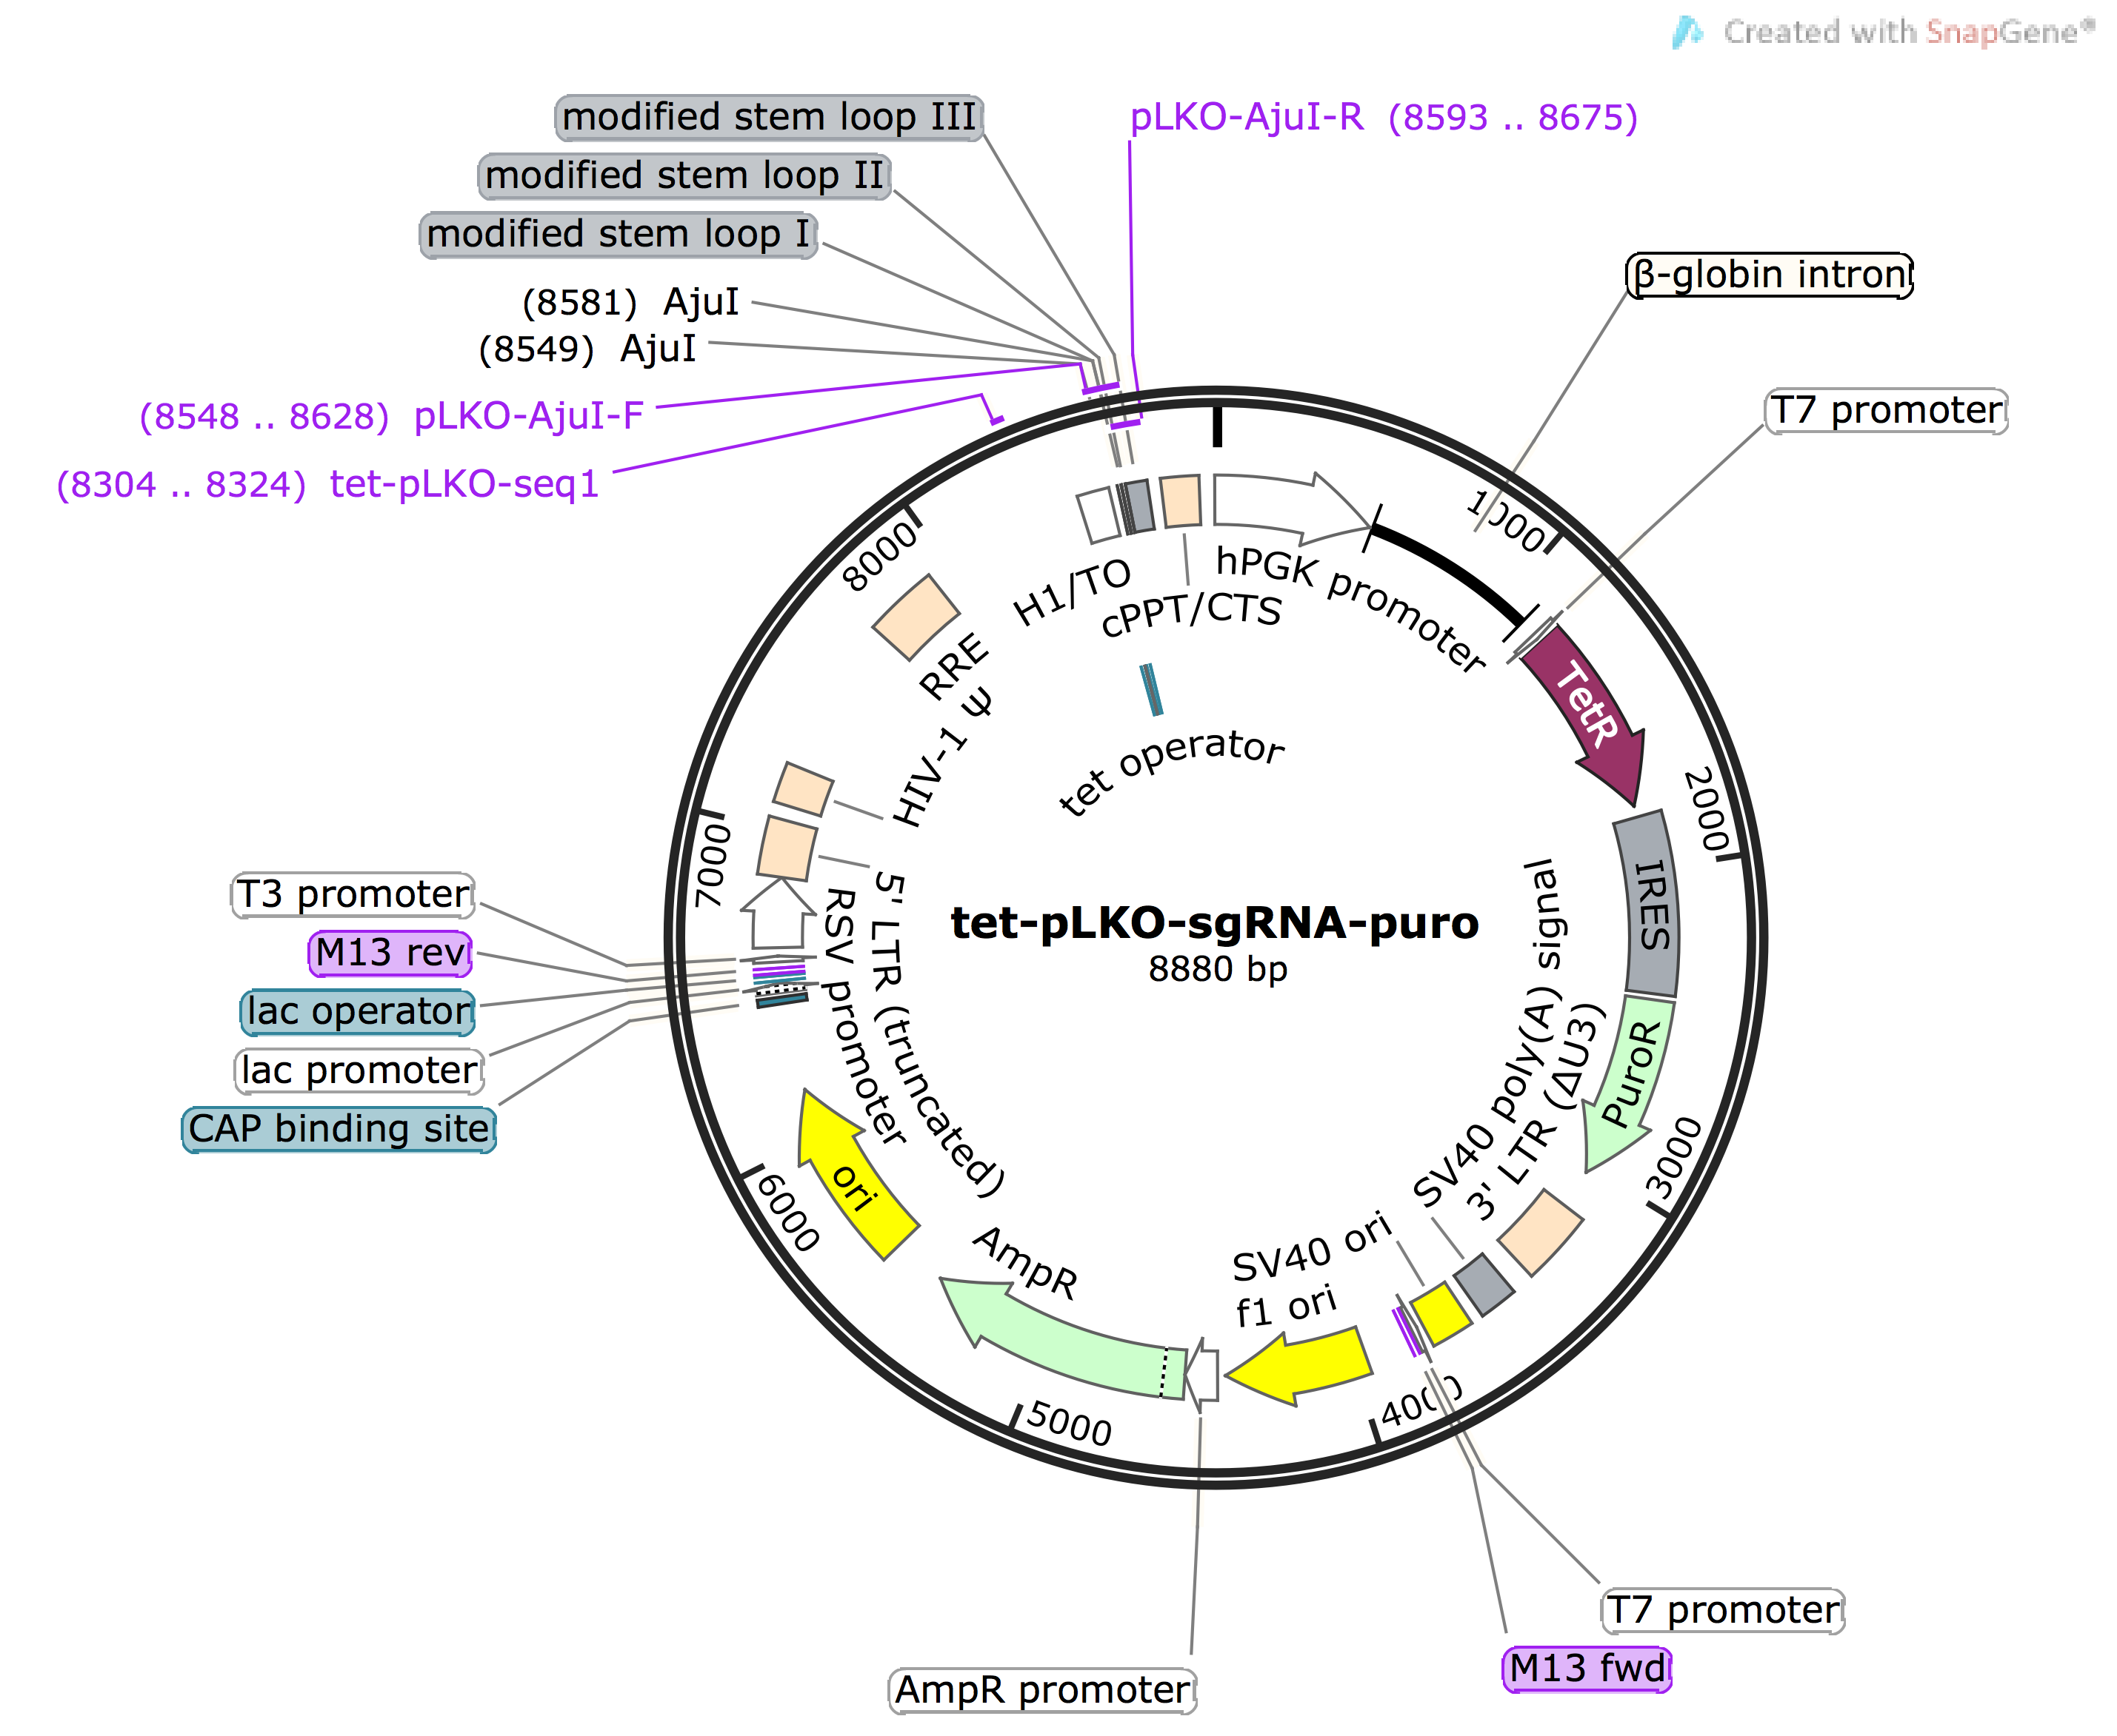

Background:
This lentiviral plasmid was designed for the purpose of doxycycline-inducible CRISPR interference (CRISPRi). Specifically, we modified tet-pLKO-puro (Addgene #21915; the Wiederschain lab), a previously described “all-in-one” doxycycline-inducible shRNA expression construct, for inducible sgRNA expression. This strategy obviates the need to construct cell lines that express a tet-responsive transcription activator/repressor. In other words, introduction of tet-pLKO-sgRNA-puro to a KRAB-dCas9-expressing cell line is sufficient for the inducible CRISPRi system. This plasmid may also find use in other CRISPR/Cas9 strategies when inducible sgRNA expression is preferred.

Vector type: Lentiviral
Bacterial resistance gene: Ampicillin
Selection marker: Puromycin
Growth strain: NEB Stable or other rec-deficient E. coli strains

sgRNA oligo design:
An AjuI cloning site is used for introducing target sequences into the plasmid. Many databases and websites (e.g. http://blog.addgene.org/how-to-design-your-grna-for-crispr-genome-editing) offer guidelines for how to design guide sequences.

Below are two examples of sgRNA, one targeting EGFP and the other targeting MELK.

sgEGFP-NT2
5’- CGACCAGGATGGGCACCACCCGTTTA-3’
3’-CTGTGGCTGGTCCTACCCGTGGTGGG -5’

sgMELK-4i
5’- CGCCGTACCAGCCGCGTCTCTCGTTTA-3’
3’-CTGTGGCGGCATGGTCGGCGCAGAGAG -5’

To complement the cut sites generated by AjuI, the oligonucleotides should contain overhangs: 5’-CNNNN…..NNNNGTTTA-3’ (forward) and 5’-NNNN….NNNNGGTGTC-3’ (reverse). If the guide sequence does not start with ‘G’, one base ‘G’ needs to be added at the 5’ end for efficient initiation of Pol III-mediated transcription, as shown in sgMELK-4i.

Oligo annealing and ligation into tet-pLKO-sgRNA-puro:
1. Reconstitute oligos in nuclease-free H₂O to 200 μM.
2. Mix 5 μL of each oligo (Forward and Reverse, 200 μM) with 2 μL of 10X Annealing Buffer (1 M NaCl, 100 mM Tris-HCl, pH=7.5, 10 mM EDTA) and 8 μL nuclease-free H₂O in PCR tubes.
3. Heat the mixtures to 95 ºC for 4 minutes, and cool down to 25 ºC for 5-10 minutes. This 50 μM stock can be stored at -20 ºC.
4. Dilute 1 μl of the 50 μM oligo mixture in 99 μl nuclease free water (1:100) for a 500 nM stock.
5. Dilute 1 μl of the 500 nM oligo mixture in 1 μl 10X Annealing Buffer and 8 μl nuclease free water (1:10) for a 50 nM stock. This stock should be freshly made.

6. Digest tet-pLKO-sgRNA-puro with AjuI (Cat#FD1954, ThermoFischer Scientific) as described in the protocol (https://www.thermofisher.com/order/catalog/product/FD1954). In brief, mix less than 1 μg of tet-pLKO-sgRNA-puro with 2 μl of 10X Fast Digest Green Buffer, 1 μl of 20X SAM (0.2 mM), and nuclease-free water to 19 μl. Add 1 μl of FastDigest AjuI to the mixture, and incubate at 37 ºC for >15 minutes.
(Note: Consider longer incubation time for more complete digestion, to minimize undigested or re-annealed plasmids in the next steps.)
7. Gel-purify the digested vector.

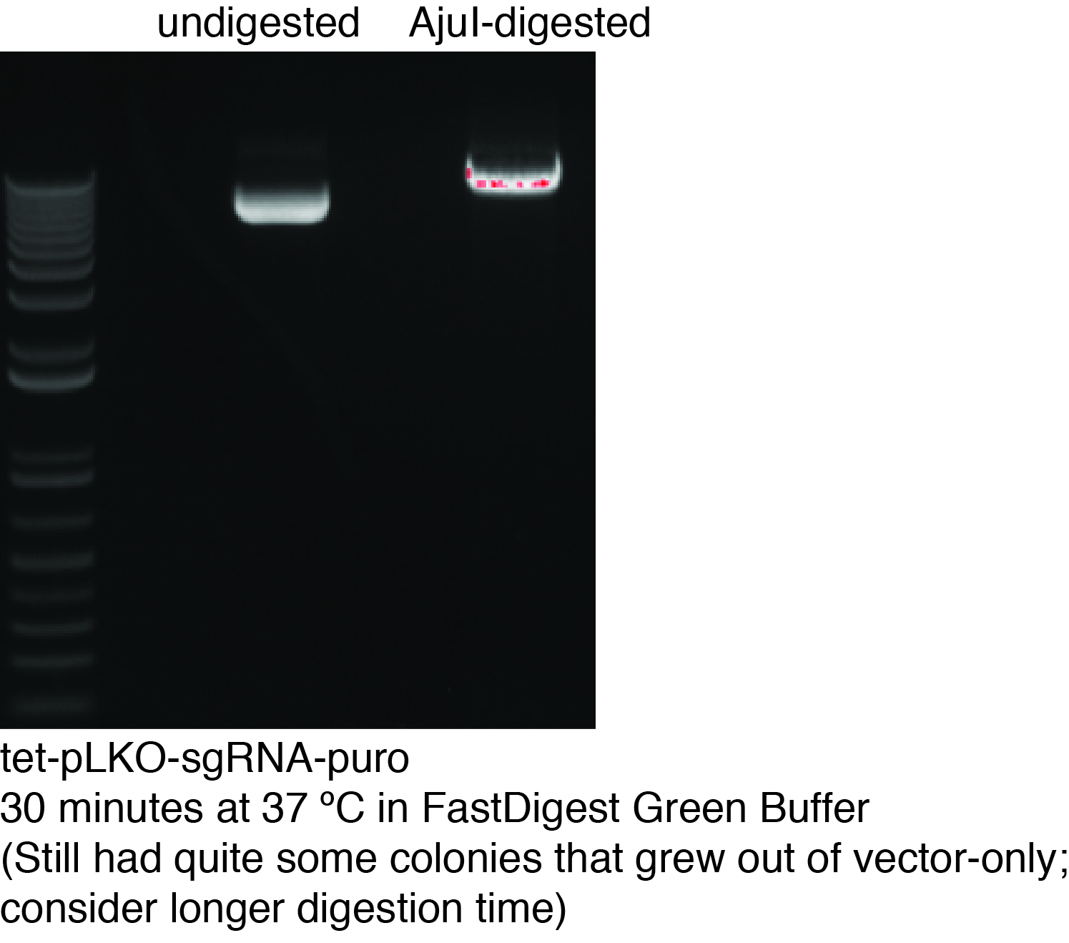
8. Set up ligation reaction as follows:
1 µl of 50 nM annealed Oligo (or nuclease-free water as Vector-only control)
30-40 ng of gel-purified AjuI-digested tet-pLKO-sgRNA-puro
2 µl 10X T4 DNA Ligase Buffer
To 19 µl: nuclease-free water
1 µl T4 DNA ligase, added last
Incubate at room temperature for > 10 minutes.
9. Always include “Vector-only” negative control to monitor vector self-ligation, or incomplete digestion. This would help you assess how many colonies need to be sequenced for at least one positive clone.

Transformation of ligation reaction product into E. coli:
We recommend using NEB Stable or other rec-deficient E. coli strains to minimize vector recombination. Transformation procedures follow standard protocols provided by most manufacturers, which involve 30-sec heat shock at 42 ºC and overnight growth on Ampicillin plates at 30 ºC.

Screening for positive clones:
Isolate individual colonies, and extract DNA by miniprep. The number of colonies to pick depends on how many colonies are present in the vector-only negative control plate. The more colonies that grow in the control plate, the more colonies need to be isolated to ensure at least one positive clone.

The DNA sequence that encodes the sgRNA in the isolated clones were confirmed by Sanger sequencing, using the following primer:
tet-pLKO-seq-1: 5’- GTTTCAGACCCACCTCCCAAC’-3
References:
Please cite this publication when using tet-pLKO-sgRNA-puro:
H. T. Huang et al., MELK is not necessary for the proliferation of basal-like breast cancer cells. Elife 6, (2017).

Useful resource: tet-pLKO-puro (Plasmid # 21915), from which tet-pLKO-sgRNA-puro was modified
D. Wiederschain et al., Single-vector inducible lentiviral RNAi system for oncology target validation. Cell Cycle 8, 498-504 (2009).

Useful resource: pHR-SFFV-KRAB-dCas9-P2A-mCherry (Plasmid # 60954), used to construct the CRISPRi system
L. A. Gilbert et al., Genome-Scale CRISPR-Mediated Control of Gene Repression and Activation. Cell 159, 647-661 (2014).

