Target Guide Sequence Cloning Protocol
In order to clone the target sequence into the lentiCRISPRv2 or lenti-sgRNA backbone, synthesise two oligos of the form:

Example oligo design: Note that the NGG PAM is not included in the designed oligos.

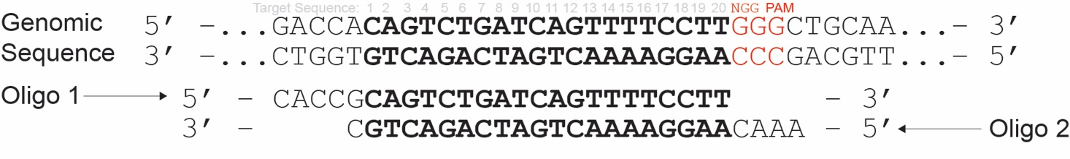
The lentiCRISPRv2 and lenti-sgRNA plasmid series have the same overhangs after BsmBI digestion and the same oligos can be used for cloning into both.
