Background:

Chemical-inducible dimerization (CIDs) domains are proteins that can be dimerized through addition of a small-molecule. Moreover, light-inducible dimerization (LIDs) domains also exist that dimerize in response to light. This set of plasmids contains three pairs of heterodimerizing CIDs and one pair of heterodimerizing LIDs. These include the rapalog-responsive FKBP/FRB, gibberellin-responsive GAI/GID1, and abscisic acid-responsive PYL/ABI CIDs and blue-light responsive nMag/pMag domains. CIDs/LIDs can be used to recruit proteins with different activities to localize the response. Moreover, CIDs/LIDs can be used to restore the activity of a split protein. This latter strategy was used to develop a large suite of inducible split recombinases.

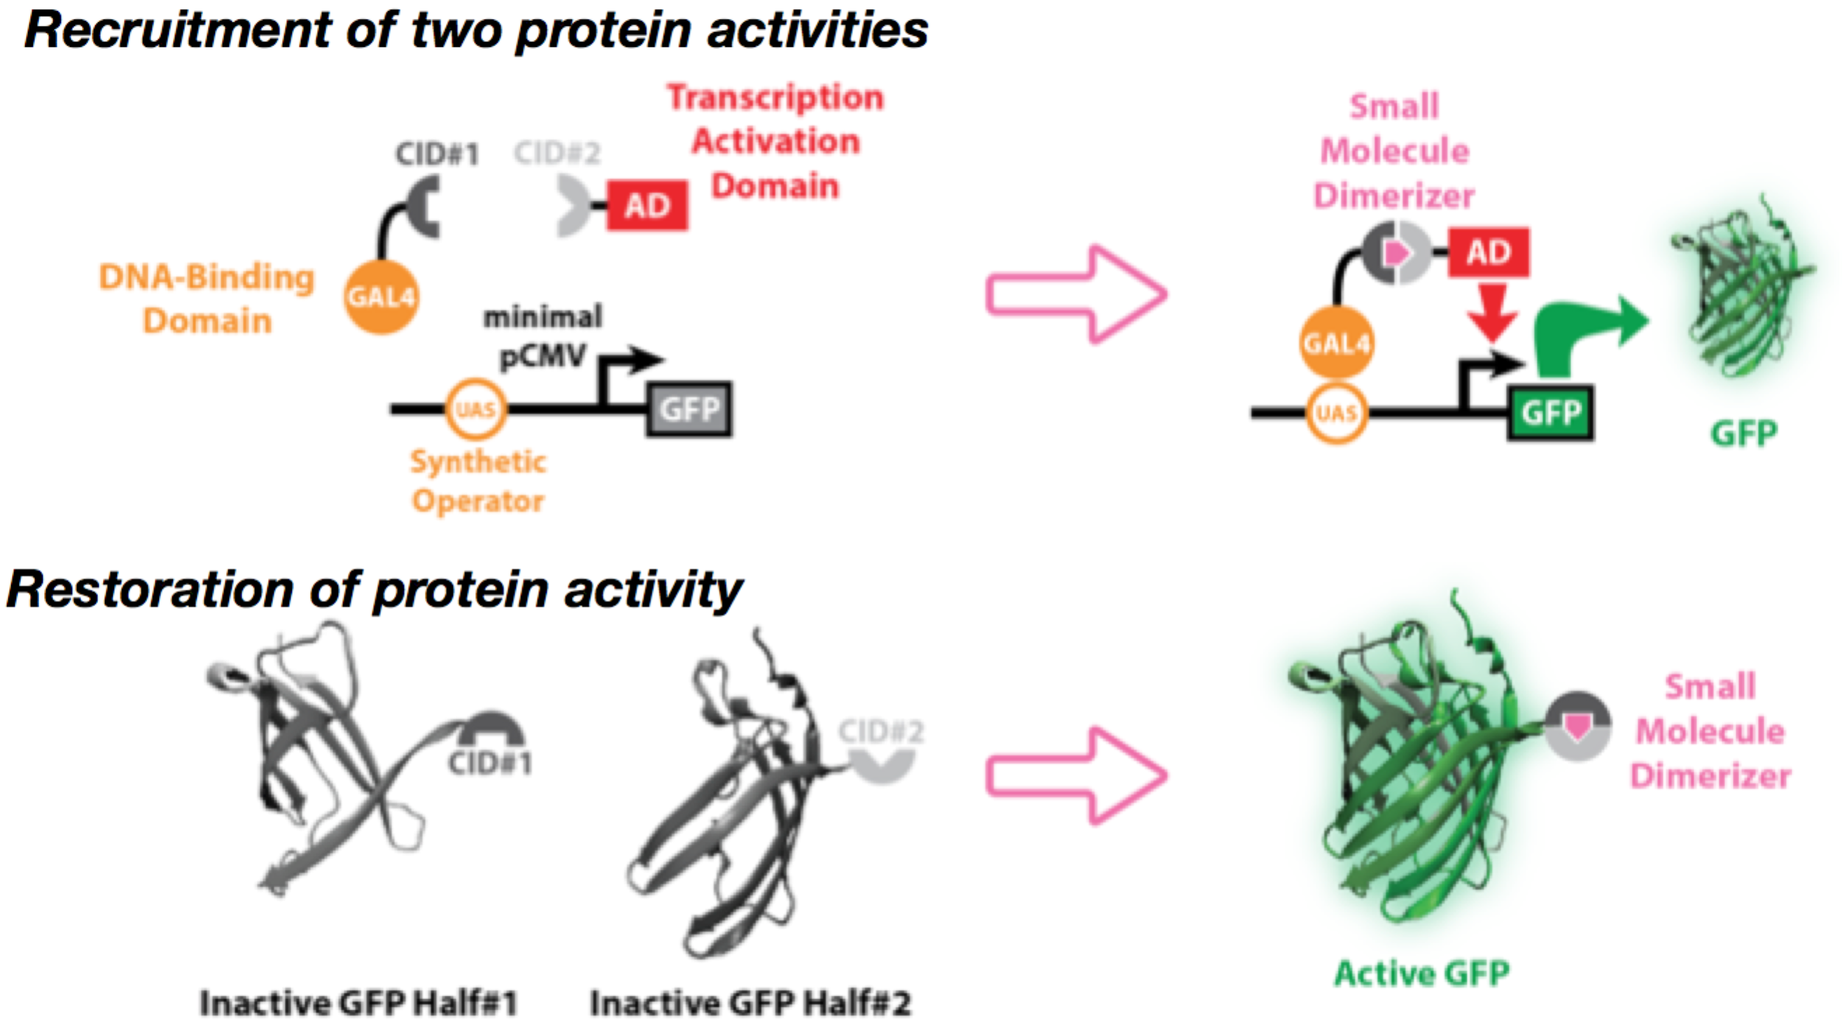
Cloning Methods to Assemble Split Recombinase Plasmids:
A series of sub-cloning vectors containing CID or LID domains were assembled using standard molecular cloning techniques or Gibson isothermal assembly. For each CID or LID, two sub-cloning vectors were made such that a recombinase could be tagged with the domain on the C-terminus or N-terminus and a glycine-serine rich linker L1 (SGGSGSGSSGGSGT) with the first SG being a BspEI restriction site and the final GT a KpnI site.

For insertion into a C-terminal CID or LID sub-cloning vector:

Recombinase “starting fragments” (N-terminal fragment) were first PCR-amplified out of a full recombinase sequence template to contain a 5’ sequence to code for an MluI restriction site and a Kozak consensus sequence, and a 3’ sequence to code for a BspEI restriction site. These PCR fragments were then isolated using agarose gel extraction and purification (Epoch Life Science). Finally, the isolated fragments were digested with MluI and BspEI restriction enzymes (New England Biolabs), purified by PCR cleanup (Epoch Life Science) and ligated into an MluI/BspEI-digested CID and LID sub-cloning vectors that were isolated by PCR cleanup (Epoch Life Science). Reaction products were transformed into chemically competent dam⁺ Top10 E. coli cells and selected on LB-agar plates with carbenicillin at 37°C static conditions. Colonies were picked the following day, inoculated into carbenicillin-containing LB medium, and grown in a 37°C shaking incubator (Infors). Once the cells were near or at stationary phase, plasmid DNA was isolated using mini plasmid preparation (Epoch Life Science). Analytical digests with MluI/BspEI were performed and run on gel electrophoresis to assay if a correct product was made. Plasmid clones with correct gel bands were sent for sequencing (Quintara Biosciences).

For insertion into a N-terminal CID or LID sub-cloning vector:

Recombinase “terminating fragments” (C-terminal fragment) were first PCR-amplified out of a full recombinase sequence template to contain a 5’ sequence to code for an KpnI restriction site and a 3’ sequence to code for an SV40 nuclear localization signal (NLS), stop codon, and an EcoRI restriction site. A similar process was followed as before with the C-terminal CID and LID sub-cloning vectors; however, KpnI-HF and EcoRI-HF restriction digests (New England Biolabs) were carried out rather than with MluI and BspEI.

To swap between CID and LID domains:

Sequenced fragments were gel-isolated from sequenced vectors using MluI/BspEI or KpnI-HF/EcoRI-HF and inserted into corresponding CID or LID sub-cloning vectors. Occasionally, the BspEI site was blocked by dam methylation and PCR fragments were utilized instead.

Cloning Schematic:

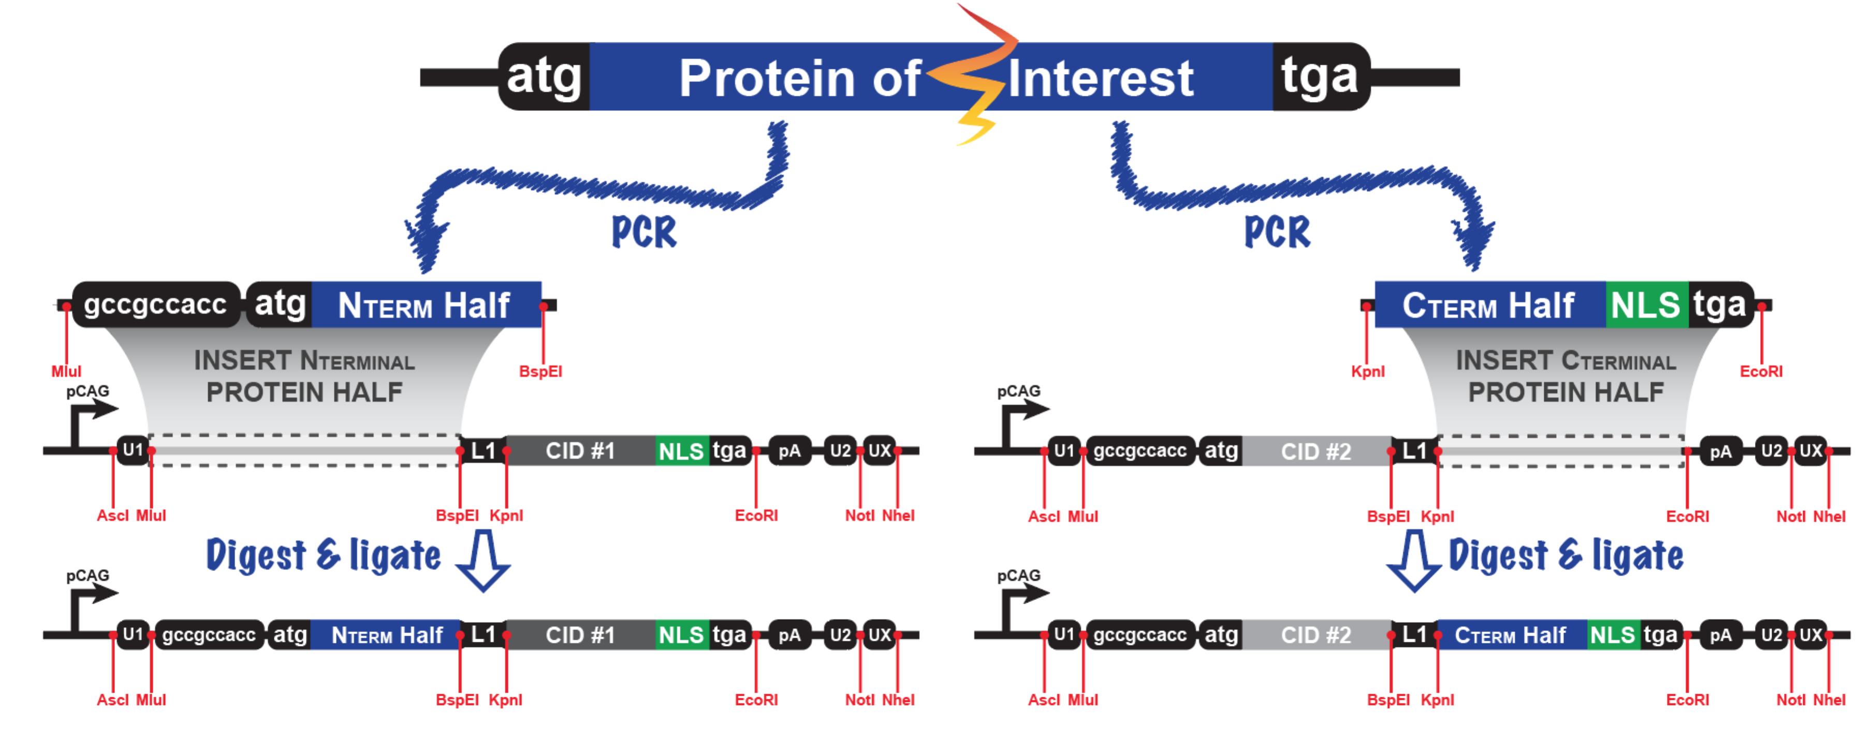
CID/LID Sub-Cloning Vectors:

