CRISPR targeting in hES cells
170616 MIA v1.4

Knock-out cells
- Design gRNAs using Benchling (or other online server)
  - Consider KO strategy; If using just one gRNA you are relying on a frameshift to take place for your KO (2/3 chance for each successful targeting event). With 1 gRNA only one targeting event needs to take place per allele. Using a pair of gRNA you can e.g. cut out all of Exon1 (or perhaps the critical functional part of the protein), but 2 targeting events per allele are needed.
  - Order a selection of the best available gRNAs, according to the predicted off target and on target scores. For pMIA3 plasmid (fig 1.) you can only use gRNAs that start with a G (due to use of eSpCas9, enhanced specificity mutant). You need at least two independent gRNAs, or pairs, for each target in order to exclude possible off target effects. However you should order more than just two for testing (perhaps 3 or 4). Not all gRNAs work as well as the prediction algorithms say. Order gRNAs as F and R oligo pairs from IDT with CACC- and AAAC- 5’ overhangs respectively.
- Amplify the target region from gDNA of target cells and clone into the MCS (e.g.SalI-site) of eGxxFP test plasmid (Addgene #50716, fig 2.).
- Ligate gRNA oligos into pMIA3 Cas9 plasmid according to CRISPR gRNA cloning protocol.
- Test gRNA efficiency by transfecting eGxxFP-target plasmid with pMIA3 gRNA/Cas9 plasmid into HEK293T cells (also have single plasmid control wells). Efficient gRNA will result in strong GFP signal. Choose the best gRNA available for targeting the final experimental cells.
  - If necessary PCR and NEBuilder-ligate multiple sgRNA cassettes into one pMIA3, digested by NheI & XhoI. This is needed if multiple sgRNAs are used for targeting.
- Use well maintained undifferentiated hES cells for targeting. 1.5x10^6 cells needed for every gRNA and control targeting. Pre-treat each well of cells used with ROCKi for at least 1h. Also prepare geltrex coated wells for each targeting.
- Use accutase to prepare single cell suspension for targeting. Use Amaxa4D nucleofector and P3 Primary Cell kit (V4XP-3024, if using 3032 kit, scale down number of cells & volumes accordingly) for targeting, with program CM-113, best for H1 line (also works with H7 and H9, program should be optimised for new hES/iPS lines). Resuspend 1.5x10^6 cells in 100µl of nucleofection solution for each target and add 10µg of Cas9 plasmid (max volume to add 10µl). Also nucleofect control cells with pCE-mp53DD plasmid (Addgene #41856, control for tp53dn function of pMIA3). After targeting wait for 2 min before adding culture media. Use mTeSR with CloneR supplement to plate out the cells.
- Change media after 24h with mTeSR and recover for another 24h.
- Use FACS to enrich for targeted cells.
  - Pre-treat the cells with ROCKi as for nucleofection and prepare appropriate number of geltrex wells.
  - Use accutase to prepare single cell suspension of the whole targeted well.
  - Spin down, resuspend in PBS and filter the cells.
- Sort out 10 000 RFP+ cells into an Eppendorf containing mTeSR with P/S and Gentamicin, for each targeting. Also sort out 10 000 of the tp53 targeted control cells.
  - Keep leftover cells and extract gDNA, can be used to check for gRNA targeting efficiency, either with PCR (for larger deletions, you can often use primers amplifying target region for eGxxFP test) or Surveyor/T7 for frameshifts. If no evidence of targeting from the extra gDNA, most likely not worth growing out and screening the clones.
- Plate out several wells of the sorted cells on 6-well plates with different number of cells (100-1000 cells per well) using mTeSR supplemented with CloneR, P/S and Gentamicin.
- After 48h change media on wells with mTeSR + CloneR.
- After 48h change media to normal mTeSR.
- Wait for colonies to grow, approx. 14 days and manually pick single colonies into 1/12 well.
- Amplify colonies and split with RelesR 1:1 in 12-wells.
- Once clones have grown enough, split again with RelesR.
  - Plate out between 1:10 to 1:20 into a new 12-well.
  - Use remaining cells for gDNA extraction.
- Screen clones for successful CRISPR targeting with PCR and sequencing.
- Expand & freeze down stocks of correctly targeted clones for downstream experiments.

HDR edited cells
- Design gRNAs using Benchling.
  - Consider targeting strategy.
    - For 2A reporter lines gRNA needs to overlap STOP codon of GOI, or alternatively 2 gRNAs either side of STOP codon can be used with nickase Cas9.
    - For SNP changes using piggyBac donor a TTAA as close as possible to the SNP of interest should be targeted. Same rules apply to gRNAs as with 2A reporter and STOP codon.
    - Other targetings, choose best gRNA available in the region of interest.
- Prepare donor plasmid with appropriate homology arms (500-2000bp) for your targeting needs (e.g. homology to either side of STOP codon or to TTAA).
- Follow steps 1b. to 7. as described above for KO cells, except that 5µg of Cas9 plasmid and 5µg of donor plasmid should be used together in the targeting.
- After 48h (or longer if cells have not recovered properly), apply selection agent to the targeted and control wells, such as puromycin or blasticidin depending on the donor used.
- Once all cells in the control wells have died and healthy colonies are growing on targeted wells manually pick single colonies into 1/12 well and follow steps 14. to 17. as above.

Note on off-targets
pMIA3 plasmid uses the eSpCas9 mutant, described in Slaymaker et. al. 2016. This has been shown to drastically reduce off target effects, but it also reduces on target efficiency. Nickase eSpCas9 can be used to further reduce off-targets, but efficiency is reduced even more. Please note that only gRNAs with a native 5’ G work well with eSpCas9 (G at the start is required by U6 promoter). A G+N₂₀ gRNA is not a perfect match and eSpCas9 will have minimal activity.
Even with eSpCas9 off-targets are still possible hence they should be addressed by either genome wide off-target screening methods (e.g. Digenome-seq, CIRCLE-seq or SITE-seq) or by having at least two independent (different gRNAs) clones for each targeting. For research applications the latter option is the best control to have; independent gRNAs have different off-targets, hence a phenotype replicated by two (or more) independent clones cannot be due to off-targeting.
If independent clones are not possible (e.g. with many HDR targetings using one gRNA) a screening method should ideally be applied to exclude off-target effects.

Fig 1. pMIA3 (1sg-eSpCas9-2AmRuby2-2Amtp53dn)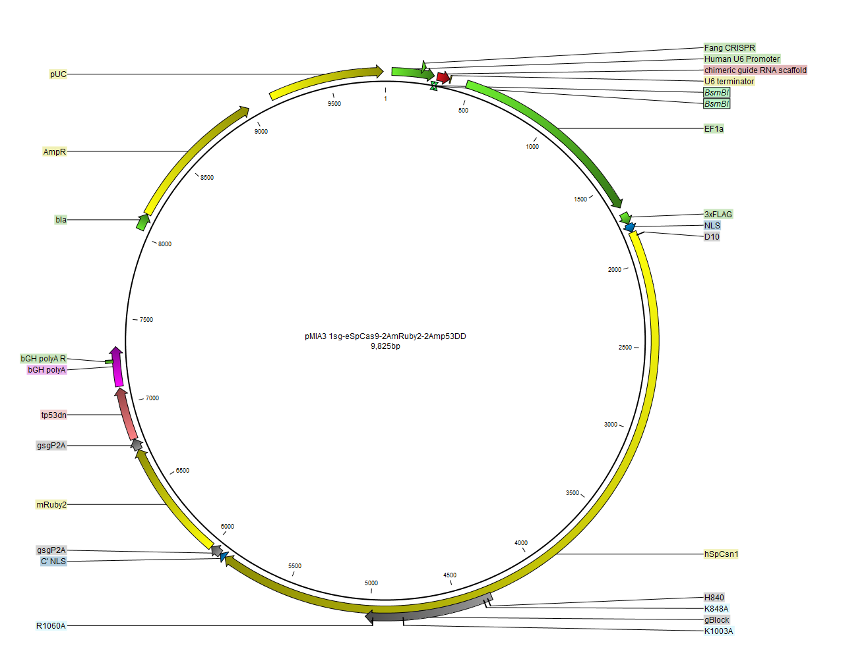
Fig 2. pCAG-eGxxFP
