Cloning Self-Cleaving Integrating Plasmids (SCIP)
Background: Self-cleaving and integrating plasmids (SCIP) contain a specific sgRNA and bait sequence that causes plasmids to self-linearize within mammalian cells, resulting in increased integration of the whole-plasmid sequence at the genomic target site. These plasmids also contain an intronic sequence within the Cas9 gene to prevent self-linearization of the plasmid when expressing/producing in bacterial cells. See Bloemberg et al 2020 for further details (https://doi.org/10.1101/2020.03.25.008276).
The cloning protocol below can be performed as a simultaneous insertion of both sgRNA and BAIT oligonucleotides or sequences can be inserted individually by excluding Eco31I or BpiI respectively.
- sgRNA and BAIT primer design
  - sgRNA target sequences should be selected using a CRISPR design tool such as CRISPOR or other in order to minimize off target editing
  - CACC and AAAC adapters should be included in sgRNA-F and –R oligos respectively
    - sgRNA oligos must NOT include a PAM sequence
    - inclusion of an additional G in sgRNA-F adapter can help increase activity but is not needed if sgRNA contains a 5’ G nucleotide
  - GCCT and TAGC adapters should be included in BAIT-F and –R oligos respectively
    - BAIT oligos must include a PAM sequence
  - See excel sheet “sgRNA and BAIT oligo designer.xlsx”

- Perform restriction ligation to clone sgRNA into pQCi backbone
  - Anneal sgRNA primers
    - In 1x Tango buffer heat 1:1 mix of primers to 95°C for 5 mins and allow to return to room temperature on the bench
  - Anneal bait primers
    - In 1x Tango buffer heat 1:1 mix of primers to 95°C for 5 mins and allow to return to room temperature on the bench
  - Combine with pSCISRR-EGFP-iFADD plasmid
Component | Amount
pQCi backbone plasmid | Up to 150 ng
- Annealed sgRNA primers  - Annealed BAIT primers  - Both sgRNA and BAIT primers | 100ng
NEB T4 ligase buffer (10X) | 2 μl
H2O | up to 18 μl
BpiI (Thermo ER1012) | 0.5 μl
Eco31I (Thermo ER0292) | 0.5 μl
T4 DNA ligase (Neb M0202L) | 0.5 μl

Run the following reaction in a thermocycler

Cycle | Temperature | Time
Ligation | 15 cycles (up to 50)  37°C  16°C | 5 min  10 min
Final | 37°C  80°C | 20 min  5 min
Hold | 4°C

- Colony PCR using U6-Test-F and appropriate sgRNA reverse primer
PCR Mix
Component | Amount
Green Taq PCR Master Mix (2X) | 5 µl
H2O | 2 µl
Forward test primer – 100uM | 0.5 µl
Reverse test primer– 100uM | 0.5 µl
DNA sample | 2ul
Thermocycler program
Cycle | Temperature | Time
Initial | 95°C | 3 min
Ligation | 25 cycles  95°C  55°C  72°C | 30 sec  30 sec  20 sec
 | 72°C | 10 min
Hold | 4°C

  - Run on a 2% gel
  - Expected result should show 2 bands ~100bp and ~450bp
  - This will make pSCIP-[gene target name]

- Miniprep positive colonies
- Electroporate or transfect plasmid(s) into appropriate target cells
- To improve the proportion of cells that are likely to integrate plasmid sequence cells can be sorted for GFP+++ expression at 24h post-plasmid transfection
- After 7-14 days in culture the rate of integration can be assessed via flow cytometry
  - Stable GFP+ cells should have integration at target site (or off-target sgRNA site)
  - Proportion of GFP+ cells should reflect efficiency of sgRNA cutting
  - Stable pSCIP cells should express both sgRNA and Cas9
Expected Cloning Results:
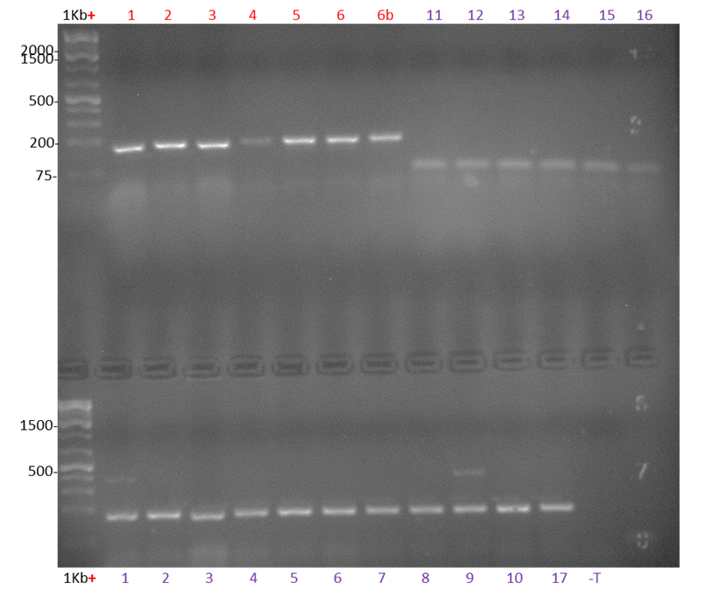
- 100% efficiency for insertion of bait along (1-6b top)
- 100% efficiency for insertion of sgRNA alone (11-16 top)
- 18% efficiency (2/11) for insertion of both BAIT and sgRNA (1-10,17 bottom)

