Pseudotyped virus protocol for coronaviruses
- SARS-CoV-1, SARS-CoV-2, MERS, NL63 pseudotyped viruses (PSVs) production
- SARS1, SARS2 and VSV-G are MLV-based retrovirus, while MERS and NL63 uses lentivirus system.
- Seed HEK293T cell to 6-well plate (1.25 million/well) or 10cm dish (7.5million cells/dish) one day before transfection.
- Gently aspirate media, add 2 ml (6-well plate) or 12 mL (10cm dish) fresh DMEM (Gibco, 10569010) complete medium (with 10% Heat Inactivated FBS and 1% P/S) to 6-well plate or 10cm dish before transfection.
- Prepare a mixture of the 3 transfection plasmids (all plasmids are Amp resistant):
a) Envelope:
SARS2-D18 (Addgene # 170442): 0.5ug for 6-well plate; 2.5ug for 10cm dish
SARS1-D28 (Addgene # 170447): 1ug for 6-well plate; 5ug for 10cm dish
VSV-G (Addgene # 8454): 1ug for 6-well plate; 5ug for 10cm dish
MERS-D12 (Addgene # 170448): 1ug for 6-well plate; 5ug for 10cm dish
NL63-D14 (Addgene # 172666): 1ug for 6-well plate; 5ug for 10cm dish
b) Gag/Pol:
MLV backbone (Addgene # 14887)
SARS2: 2.5 ug for 6-well plate; 12.5 ug for 10cm dish
SARS1: 1.5 ug for 6-well plate; 7.5 ug for 10cm dish
VSV-g: 2ug for 6-well plate; 10ug for 10cm dish
Lenti backbone: pCMV-delta-R8.2 (Addgene # 12263)
MERS: 1.5 ug for 6-well plate; 7.5 ug for 10cm dish
NL63: 1.5 ug for 6-well plate; 7.5 ug for 10cm dish
c) Reporter:
pCMV-FLuc (Addgene # 170575) for MLV
SARS2: 2ug for 6-well plate; 10ug for 10cm dish
SARS1: 2ug for 6-well plate; 12.5ug for 10cm dish
VSV-G: 2ug for 6-well plate; 10ug for 10cm dish
pBOBI-FLuc (Addgene # 170674) for lentivirus
MERS: 2ug for 6-well plate; 12.5ug for 10cm dish
NL63: 2ug for 6-well plate; 12.5ug for 10cm dish

Note: VSVG PSVs should infect both WT HeLa and HeLa-ACE2 cells; SARS-CoV-1
and SARS-CoV-2 and NL63 PSVs can only infect HeLa-ACE2 cells; MERS PSV only infects HeLa-DPP4. Cell lines were generated by stably transfecting HeLa with either ACE2 or DPP4.

- Use Lipo2000 from Invitrogen to do the transfection (1ug plasmids/ 2.5ul lipo2000). Other transfection reagents can be used according to manufacturer’s instructions.
- Gently aspirate media, add 5ml or 25 mL fresh DMEM complete medium 12-16 hours post transfection to each well of 6-well plate or 10cm dish respectively.
- Collect the supernatants (PSVs) 48 hours post transfection, spin down at 1000g for 10min to get rid of the cell pellets (Alternative: go through 0.45um filter). Aliquot and freeze at -80 for long-term storage.

Optional: You can add another 5 / 25mL fresh DMEM complete medium, incubate for 24 hours and collect PSVs again (72 hours post transfection).

- PSV infection assay (Modified from Elise’s HIV neutralization protocol)

- Serial dilution of antibody or serum with a suitable starting concentration from Row A to H in 96-well plate.
- Transfer 25ul of diluted antibody or sera to each well of 96-well half area well plate (Corning® 96 Half Area, # 3688)
- Add 25ul virus to columns 1-11, and 25ul fresh medium to column 12 (Cells only control).
- Spin down and incubate at incubator for 1hour.
- Prepare HeLa-ACE2 (or DPP4) cells in the meanwhile.
- Count and dilute cells to 200,000/ml.
- Add DEAE-dextran (Stock 10mg/ml, 500 X, Sigma, # 93556-1G) to the HeLa-ACE2 cells at a final concentration of 20ug/ml.
- Directly add 50ul of cells to the Ab/Virus or Serum/Virus mixture into 96-well plate.
- Incubate 48 hours in the incubator.
- Read the plate
- Prepare 1 X lysis buffer (25mM Gly-Gly pH 7.8, 15mM MgSO₄, 4mM EGTA, 1% Triton X-100, you can make 10X stock and store at 4 degree)
- Prepare luciferase substrate: Dilute Bright-glo substrate (Promega, #E2650) 10 fold in 1 x lysis buffer.
- Aspirate medium from the wells
- Add 50ul/well diluted luciferase substrate and incubate for >1min. (Do not incubate for more than 10min)
- Luciferase intensity is read on a luminometer

Layout template.
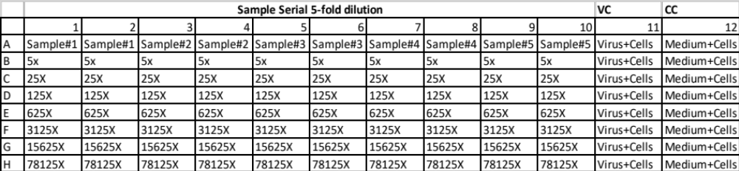

% Neutralization=$100*(1-\frac{RLU of sample-Average RLU of CC}{Average RLU of VC-Average RLU of CC}$)

Note:
If you still have questions, please refer to the Protocol for Neutralizing Antibody Assay for HIV-1 in TZM-bl Cells. You can find the equation to calculate % neutralization of serum or antibody.
https://www.hiv.lanl.gov/content/nab-reference-strains/html/Protocol-for-Neutralizing-Antibody-Assay-for-HIV-1-in-TZMbl-cells_Nov2018.pdf
https://www.ncbi.nlm.nih.gov/pmc/articles/PMC4040342/
Figures
(a)
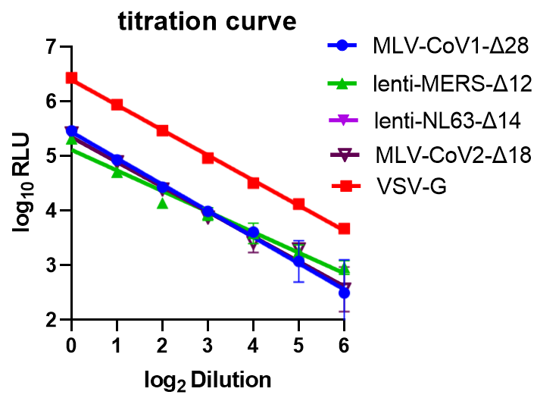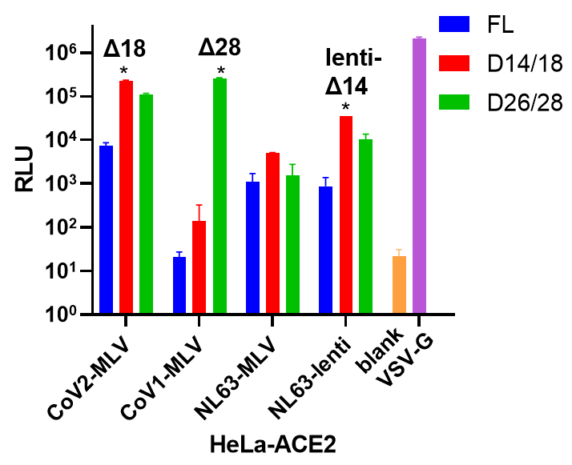
(b)
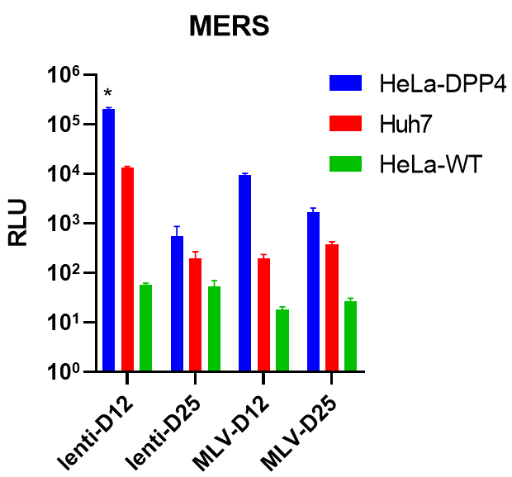
Viral titer measure: (a) Serial dilution (x2 fold) for different PSVs involved. RLU: relative luminescence unit.
(b) Different c-terminal deletions affect viral titer. FL: full length. Δn: n amino acid deletion from the c-terminal. Each version with the highest viral titer is marked with an asterisk. All the PSVs were tested on HeLa-ACE2 cells.
(c) MERS viral titer in different cell lines.
(c)

Protocol credit to Deli Huang, Linghang Peng and David Nemazee
Contact nemazee@scripps.edu for more information

