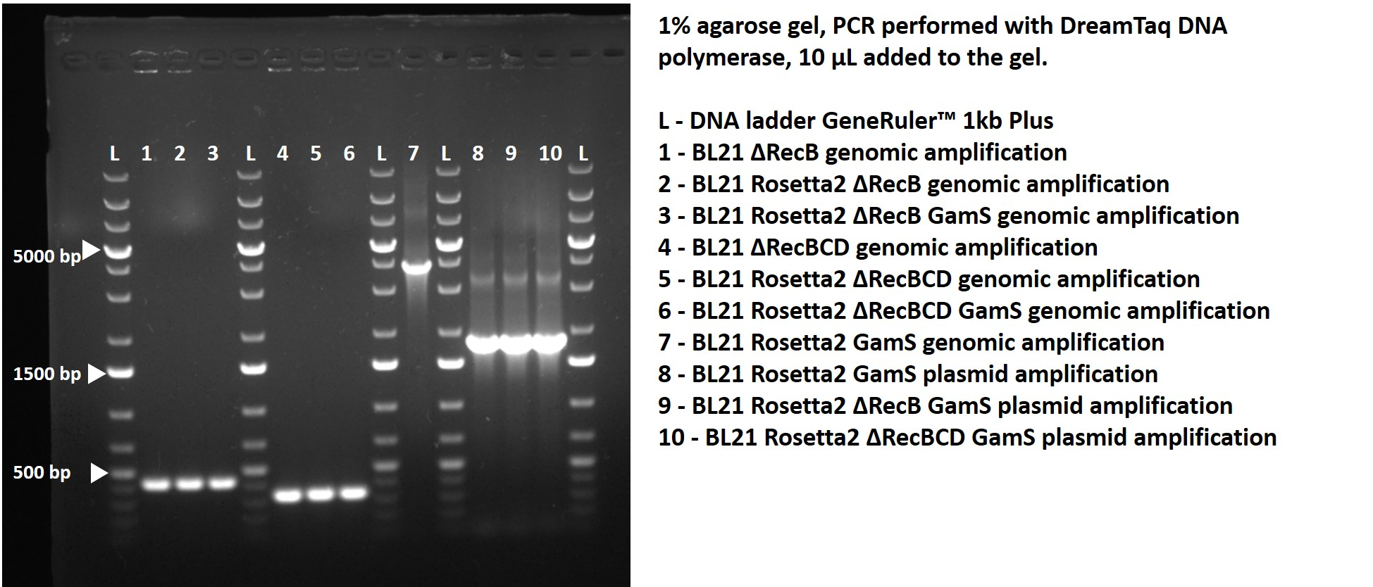

Expected sizes of amplified fragments:
1 - 442 bp - BL21 ΔRecB genomic amplification
2 - 442 bp - BL21 Rosetta2 ΔRecB genomic amplification
3 - 442 bp - BL21 Rosetta2 ΔRecB GamS genomic amplification
4 - 352 bp - BL21 ΔRecBCD genomic amplification
5 - 352 bp - BL21 Rosetta2 ΔRecBCD genomic amplification
6 - 352 bp - BL21 Rosetta2 ΔRecBCD GamS genomic amplification
7 - 3891bp - BL21 Rosetta2 GamS genomic amplification
8 - 1845 bp - BL21 Rosetta2 GamS plasmid amplification
9 - 1845 bp - BL21 Rosetta2 ΔRecB GamS plasmid amplification
10 - 1845 bp - BL21 Rosetta2 ΔRecBCD GamS plasmid amplification

