CRISPR-Cas9 mouse reagent description

CRISPR-Cas9 is a versatile genome editing technology for studying the function of genetic elements. To broadly enable the application of Cas9 in vivo and ex vivo, we established Cre-dependent and constitutively expressing Cas9 knockin mice (Platt et al., Cell 2014). In these mice the CRISPR-Cas9 system can be implemented by delivering Cre and sgRNA to a Cre-dependent mouse or sgRNA to a constitutively Cas9-expressing mouse. Described here are AAV vectors that can be combined with Cas9 in a wide range of applications.

List of plasmids described below:

1. AAV:ITR-U6-sgRNA(Kras)-U6-sgRNA(p53)-U6-sgRNA(Lkb1)-pEFS-Rluc-2A-Cre-shortPA-KrasG12D_HDRdonor-ITR (AAV-KPL)
2. AAV:ITR-U6-sgRNA(LacZ)-pEFS-Rluc-2A-Cre-WPRE-hGHpA-ITR
3. AAV:ITR-U6-sgRNA(backbone)-pEFS-Rluc-2A-Cre-WPRE-hGHpA-ITR
4. AAV:ITR-U6-sgRNA(NeuN)-pCBh-Cre-WPRE-hGHpA-ITR
5. AAV:ITR-U6-sgRNA(LacZ)-pCBh-Cre-WPRE-hGHpA-ITR
6. AAV:ITR-U6-sgRNA(backbone)-pCBh-Cre-WPRE-hGHpA-ITR
7. AAV:ITR-U6-sgRNA(NeuN)-hSyn-Cre-2A-EGFP-KASH-WPRE-shortPA-ITR
8. AAV:ITR-U6-sgRNA(backbone)-hSyn-Cre-2A-EGFP-KASH-WPRE-shortPA-ITR

CRISPR-Cas9 Cre expression vectors for cancer modeling
Using Cas9 mice, Platt et al. simultaneously modeled the dynamics of KRAS, p53 and LKB1, the top three significantly mutated genes in lung adenocarcinoma. Delivery of a single AAV vector (AAV-KPL) in the lung generated loss-of-function mutations in p53 and Lkb1, as well as homology directed repair-mediated Kras^{G12D} mutations, leading to macroscopic tumors of adenocarcinoma pathology. These plasmids as well as a backbone plasmid for cloning new targets are described here.

1. AAV:ITR-U6-sgRNA(Kras)-U6-sgRNA(p53)-U6-sgRNA(Lkb1)-pEFS-Rluc-2A-Cre-shortPA-KrasG12D_HDRdonor-ITR (AAV-KPL)
This plasmid contains two expression cassettes, Renilla luciferase-2A-Cre recombinase and sgRNAs targeting the mouse genes: Kras, p53, and Lkb1. This plasmid also contains a Kras^{G12D} homology directed repair donor template

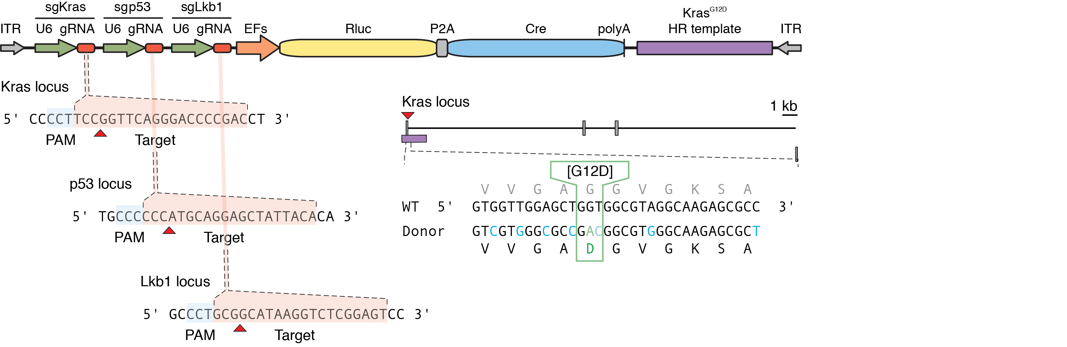

2. AAV:ITR-U6-sgRNA(LacZ)-pEFS-Rluc-2A-Cre-WPRE-hGHpA-ITR
This plasmid contains two expression cassettes, Renilla luciferase-2A-Cre recombinase and an sgRNA targeted to LacZ, which is not present within the mouse genome. This plasmid is used as a control for AAV-KPL.

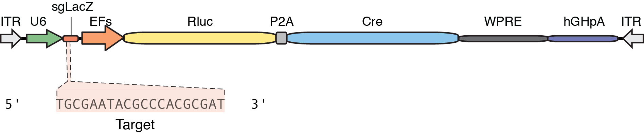

3. AAV:ITR-U6-sgRNA(backbone)-pEFS-Rluc-2A-Cre-WPRE-hGHpA-ITR
This plasmid contains two expression cassettes, Renilla luciferase-2A-Cre recombinase and an sgRNA backbone for cloning new targeted plasmids. The plasmid can be digested using SapI, which will reveal sticky ends to enable the rapid ligation of annealed and phosphorylated oligos designed based on the target site sequence (20bp). The cloning protocol can be found below.

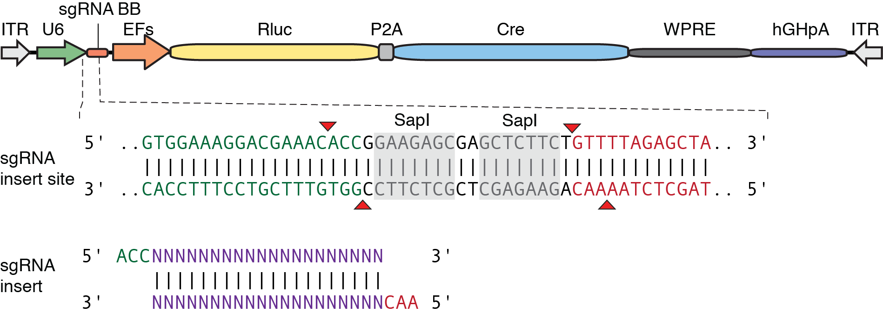

CRISPR-Cas9 Cre expression vectors for genome editing in the brain
Using Cas9 mice Platt et al. demonstrated in vivo genome editing in the brain by AAV-mediated expression of an sgRNA targeting the neuronal-specific gene NeuN. As a control they designed an sgRNA targeting LacZ, which is not present in the mouse genome. These plasmids are described here.

4. AAV:ITR-U6-sgRNA(NeuN)-pCBh-Cre-WPRE-hGHpA-ITR
This plasmid contains two expression cassettes, Cre recombinase and an sgRNA targeted to the mouse NeuN gene.

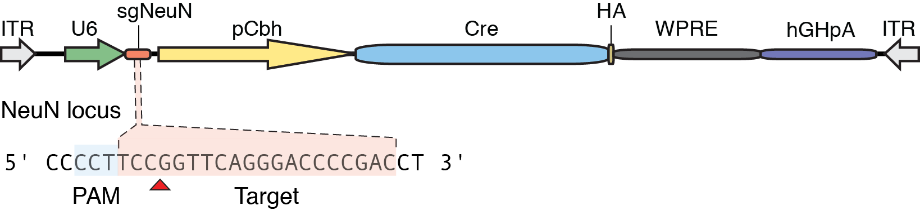

5. AAV:ITR-U6-sgRNA(LacZ)-pCBh-Cre-WPRE-hGHpA-ITR
This plasmid contains two expression cassettes, Cre recombinase and an sgRNA targeted to LacZ, which is not present within the mouse genome.

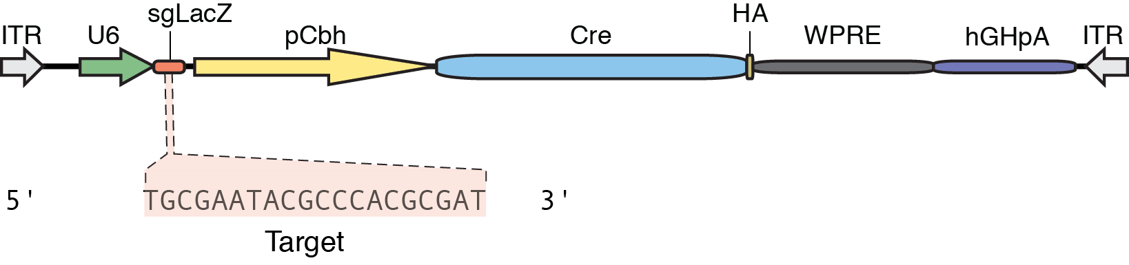

6. AAV:ITR-U6-sgRNA(backbone)-pCBh-Cre-WPRE-hGHpA-ITR
This plasmid contains two expression cassettes, Cre recombinase and an sgRNA backbone for cloning new targeted plasmids. The plasmid can be digested using SapI, which will reveal sticky ends to enable the rapid ligation of annealed and phosphorylated oligos designed based on the target site sequence (20bp). The cloning protocol can be found below.

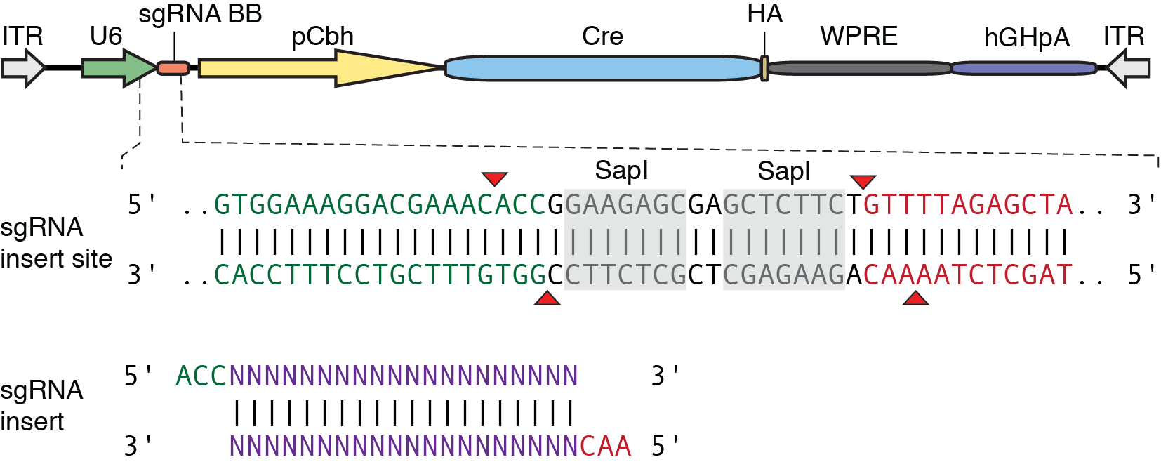

7. AAV:ITR-U6-sgRNA(NeuN)-hSyn-Cre-2A-EGFP-KASH-WPRE-shortPA-ITR
This plasmid enables Cre/loxP recombination and fluorescence assisted sorting of cells and nuclei in addition to sgRNA expression. This plasmid contains two expression cassettes, Cre recombinase-2A-EGFP-KASH and an sgRNA.

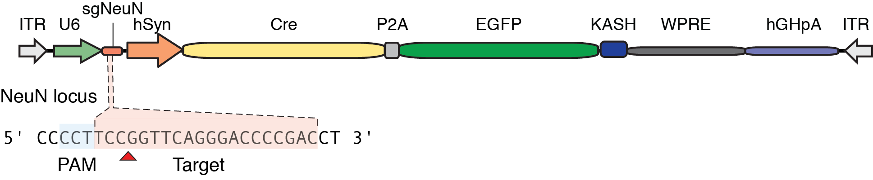

8. AAV:ITR-U6-sgRNA(backbone)-hSyn-Cre-2A-EGFP-KASH-WPRE-shortPA-ITR
This plasmid facilitates Cre/loxP recombination and fluorescence assisted sorting of cells and nuclei in addition to sgRNA expression. This plasmid contains two expression cassettes, Cre recombinase-2A-EGFP-KASH and an sgRNA backbone for cloning new targeted plasmids. The plasmid can be digested using SapI, which will reveal sticky ends to enable the rapid ligation of annealed and phosphorylated oligos designed based on the target site sequence (20bp). The cloning protocol can be found below.

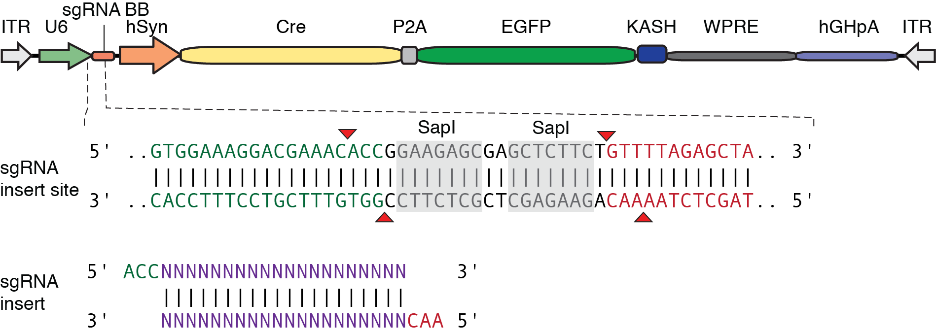

Cloning protocol

Backbone vector digestion

Vector backbone DNA (1 μg) x μl
FastDigest 10x buffer (Thermo) 5 μl
SapI (LguI) FastDigest (Thermo) 4 μl
FastAP (Thermo) 1 μl
H2O x μl
Total 50 μl

-Incubate at 37°C for 1 hour.
-Purify the digested vector by gen purification (QIAquick Gel Extraction Kit (Qiagen)).

Oligo phosphorylation/annealing reaction

Top oligo (100 μM) 1 μl
Bottom oligo (100 μM) 1 μl
Buffer A 10x (Thermo) 2 μl
ATP (25 mM) 1 μl
H₂O 14 μl
PNK (Thermo) 1 μl
Total 20 μl

-Incubate at 37°C for 30 min, 95°C for 5 min, ramp to 4°C by 0.1°C/sec.

Ligation

Digested vector (25 ng) x μl
Phosphorlyated/annealed olgios (1:50) 1 μl
Rapid Ligation Buffer 2x (Enzymatics) 1 μl
T7 Ligase (Enzymatics) 0.75 μl
H20 x μl
Total 10 μl

-Prepare a negative control reaction by excluding Digested vector.
-Incubate at room temperature for 10 min.

Transformation

Transform 1 μl of ligation reaction mixture in 25 μl of Z-competent (Zymo) Stbl3 E. coli (Life).

Sequencing

Prepare a mini prep for 1-4 colonies (QIAprep Spin Miniprep Kit (Qiagen)). Sequence purified plasmid using a U6-Forward sequencing primer: 5’-GAGGGCCTATTTCCCATGATTC-3’.

Reagents:

SapI (LguI) FastDigest (Thermo) # FD1934
FastAP (Thermo) # EF0654
PNK (Thermo) # EK0031
QIAquick Gel Extraction Kit (Qiagen) # 28704
T7 Ligase (Enzymatics) # L6020L
Z-competent (Zymo) # T3001
Stbl3 E. coli (Life) # C7373-03
QIAprep Spin Miniprep Kit (Qiagen) # 27104

