For introduction of point mutations, deletions, and short insertions into the E. coli genome. Your mutation/alternate sequence is introduced from ssDNA or dsDNA using homologous recombination facilitated by the λ-Red system. The wild-type sequence is selected against using the sgRNA/Cas9 system, resulting in enrichment of cells containing your desired mutation.
You will need:
- pKDsgRNA-XXX plasmid as template, SpecR and temperature sensitive
- primers to clone your protospacer into the pKDsgRNA plasmid using CPEC or Gibson cloning
- oligo / dsDNA with desired mutations / modifications
- pCas9CR4 plasmid, CmR
** Note: can do steps 1-3 and 4 in parallel.
- Design primers for cloning your protospacer (target) into the pKDsgRNA plasmid. The protospacer must precede a PAM site of NGG on either strand. The diagram below demonstrates the primer design for targeting a PAM on either strand.
  - Add this sequence to the 3’ end of the forward primer - gttttagagctagaaatagcaag
  - Add this sequence to the 3’ end of the reverse primer - gtgctcagtatctctatcactga
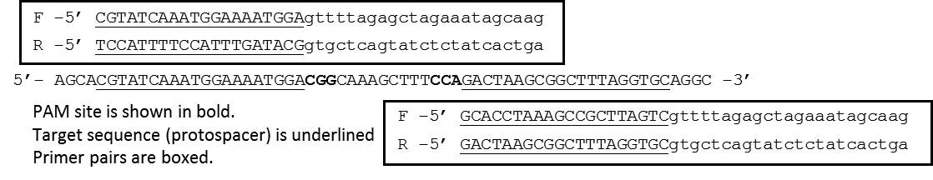
- Clone your specific target into the pKD plasmid. Do this by two PCR reactions to amplify the 7 kb plasmid in two parts – 3 kb and 4 kb, then CPEC the two parts together.
  - To amplify part 1: use your designed F primer with this primer: tttataacctccttagagctcga
  - To amplify part 2: use your designed R primer with this primer: ccaattgtccatattgcatca
  - DpnI digest and gel purify. Then set up the CPEC reaction. Transform into DH5alpha or other cloning strain. Plate on Spec (50 ug L⁻¹) and grow at 30C. Should see colonies after ~ 20 hours.
- Can verify correct cloning by sequencing. See end of protocol.
- Transform desired host strain with the Cas9 plasmid, grow on Cm at 37C.
- Grow the host strain with the Cas9 plasmid at 37C + Cm, and transform with the new pKD plasmid which contains your protospacer. (Do not attempt to do a double transformation with the pKD plasmid and Cas9).
- After the recovery step at 30C, plate on Spec/Cm/+aTC and on Spec/Cm – no aTC. aTC induces Cas9 and so should see a lot fewer colonies on that plate if everything worked properly.
- Take 1-3 big colonies from the no aTc plate and grow up in Spec/Cm at 30C. At OD 0.4 – 0.5, add arabinose (1.2% final concentration), to induce λ-Red recombinase. Incubate for an additional 15 minutes.
- Then, make the cells electrocompetent. Transform with 200-1000 ng of dsDNA or 1-10 µM ssDNA. If using a gBlock we typically PCR amplify in 50 µl, purify, and use half the amount for the transformation.
- At this point, it would be useful to also include a control DNA transformation. This can be any sequence of similar length and serves to account for cell death during electroporation.
- Recover at 30C, then plate on Spec/Cm/+aTC. Plate only ~ 1ul or do serial dilutions. Expect to see a lot more 2-500-fold more colonies on the experimental plate.
- Verify correct mutation by PCR / sequencing / restriction digest, etc.
- To cure plasmids: first cure the pKDsgRNA plasmid. Grow up in liquid culture at 37C for 4-24 hours, then streak out, and incubate at 37C. Check for Spec sensitivity.
- Then, transform with pKD-kill plasmid, which is SpecR and temperature sensitive.
- Grow up, induce with aTC in liquid culture. Plate on Spec + aTC at 30C.
- Patch individual colonies on Cm + / Cm- at 37C. Passage one more time to make sure that the pKD plasmid has been cured.
Primers to verify protospacer in pKD plasmid: ~ 1kb product; Ta= 50C with OneTaq
pKD_Seq5 = CAGTGAATGGGGGTAAATGG
sgRNA_R = GCCTGCAGTCTAGACTCGAG
Submit for sequencing with sgRNA A primer = AGCTTTCGCTAAGGATGATTT

