Strategy for constructing homologous donor containing piggyBAC cassette
(Supplemental document for paper Ye. et al PNAS 2014, 111(26): 9591-6. 2014. PMID:
24927590. )

We used PCR method to connect 5’ homologous arm and 3’ homologous arm to piggyBac cassette.

Three steps PCR reactions will be designed for connecting arms with cassette.

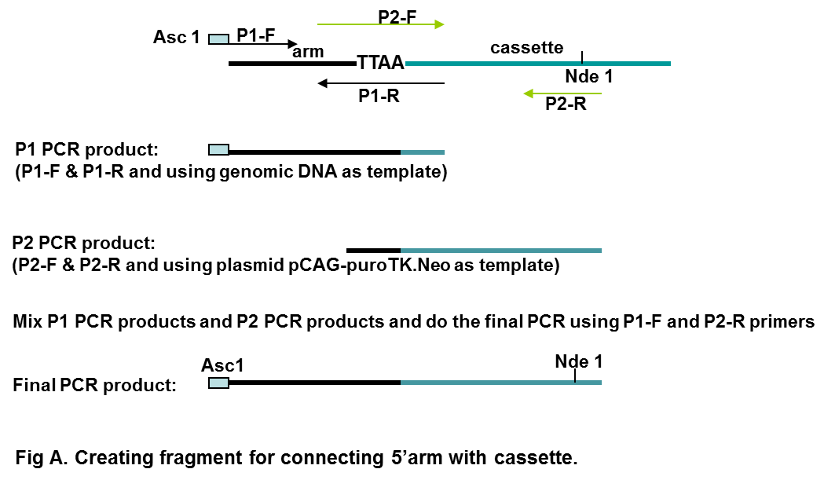

P1-F: 5’GTGGCGCGCCXXXXXXXXXXXXXXXXXXXXX3’
P1-R: 5’aattttacgcagactatctttctagggttaaNNNNNNNNNNNNNNNNNNNN 3’

P2-F: 5’ nnnnnnnnnnnnnnnnnnnnnnnnnnttaaccctagaaagatagtctgc3’
P2-R (CAG-Nde1 AS) : 5’ GCG TAC TTG GCA TAT GAT ACA CTT

Note: N & n are complementary sequences; TTAA is included in the primer, thus the Ns is the sequences flanking the TTAA site of the genome.

The final PCR product will be digested with Asc 1 & Nde1, fragment of AscI and NdeI should be gel purified and will be used for later 4 pieces ligation.
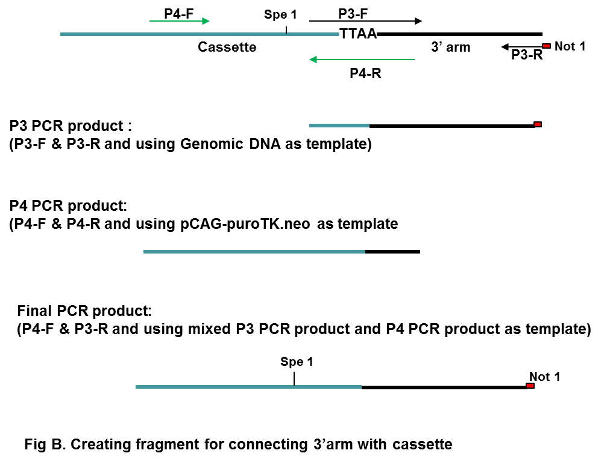

P4-F: 5’ GAC AAT TAA TCA TCG GCA TAG TAT ATC GGC
P4-R: 5’ nnnnnnnnnnnnnnnnnnnnnttaaccctagaaagataatcatattgt

P3-F: 5’ acaatatgattatctttctagggttaaNNNNNNNNNNNNNNNNNNNN
P3-R: 5’ GGGCGGCCGCXXXXXXXXXXXXXXXXXXXX

Note: N&n are complementary sequences; TTAA is included in the primer, so the sequences N should be the TTAA site flanking sequences.
The final PCR product will be digested with Spe 1 & Not 1, fragment of Spe 1 and Not1 should be gel purified and will be used for later 4 pieces ligation.

The final construct could be realized by 4 pieces ligation of a fragment of ASC1-Nde 1( from 5’ arm PCR product), a fragment of Nde 1-Spe1 from pCAG-puroTK.neo, a fragment of Spe 1 and Not 1( from 3’ arm PCR product) and a fragment of vector back bone of ASC 1-Not1.

