gRNA Design
The targeting RNA is chosen based on where you want to make the edit.
Choose 20nt that are directly preceded by a PAM sequence (TTN or CTN) anywhere that you would like but preferably within 20nt of the change that you want to make. This is your genomic target. The PAM is not part of the 20 nt but directly precedes it.
Example:
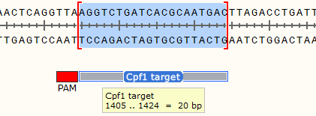
Order complimentary primers with the target sequence. These will be annealed and ligated into the cloning vector. Include the following 5’ overgangs for cloning.
F primer – agat
R primer – agac

Example:
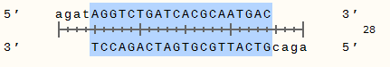

You must clone the gRNA in before the repair template

Homologous Repair Template Design
Using Gibson Assembly, you can construct repair templates to make any change to the genome that you desire.

I typically use 750bp of homology on either side of the edit but less may be sufficient.
Your repair template must not contain a PAM or cpf1 will cleave the plasmid too.
- For making a deletion make sure that the cpf1 target is in the deleted region
- For point mutations you must make a second silent mutation to eliminate the PAM
- For knock-ins use the insertion to split the cpf1 target and eliminate recognition

For Gibson assembly into the kpnI site of the vector, your homology template should have the following overhangs on the far L and R ends:
Upstream overhang – catttttttgtctagctttaatgcggtagttGGTACC
Downstream overhang - gcccggattacagatcctctagagtcgacGGTACC

