**Target Guide Sequence Cloning Protocol**

In order to clone the target sequence into the lentiCRISPRv2 or lenti-sgRNA backbone, synthesise two oligos of the form:



*Example oligo design*: Note that the NGG PAM is **not** included in the designed oligos.

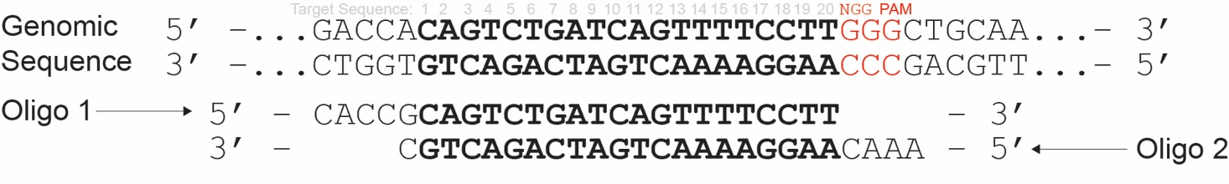

The lentiCRISPRv2 and lenti-sgRNA plasmid series have the same overhangs after *BsmBI* digestion and the same oligos can be used for cloning into both.

